SOUL SUPPORT

submitted for

STATISTICAL MACHINE LEARNING - cset211

A PROJECT REPORT

BY

Name. : ROHAN SHARMA

E23CSEU1460

SUBMITTED TO. YAJNASENI DASH

SCHOOL OF COMPUTER SCIENCE ENGINEERING AND TECHNOLOGY, BENNETT UNIVERSITY

GREATER NOIDA, 201310, UTTAR PRADESH, INDIA

April 2025

# DECLARATION

I/We hereby declare that the work which is being presented in the report entitled “Project Title”, is an authentic record of my/our own work carried out during the period from JAN, 2023 to April, 2023 at School of Computer Science and Engineering and Technology, Bennett University Greater Noida.

The matters and the results presented in this report has not been submitted by me/us for the award of any other degree elsewhere.

Signature of Candidate

# ACKNOWLEDGEMENT

I/We would like to take this opportunity to express my/our deepest gratitude to my/our mentor, **Dr. IJKL (**Provide correct name & designation) for guiding, supporting, and helping me/us in every possible way. I/we was/were extremely fortunate to have him as my/our mentor as he provided insightful solutions to problems faced by me/us thus contributing immensely towards the completion of this capstone project. I/We would also like to express my/our deepest gratitude to VC, DEAN, HOD, faculty members and friends who helped me/us in successful completion of this capstone project. Any other name you can mentioned here. (Acknowledgement is your personal view, so you can write it in your way by maintaining integrity of technical report).

Signature of Candidate

T

ABSTRACT

Soul Support is an AI-based mental health assistant uniting therapeutical methods and Large Language Model (LLM) capabilities. The platform operates with Groq's Llama3-70b model for natural language processing, ChromaDB for knowledge storage, and Gradio for UI. The main functionalities are tracking moods, meditation assistance, breathing techniques, and crisis resource integration, all the things that prompt mental health support and at the same time keep privacy.

1. INTRODUCTION

MENTAL HEALTH CHALLENGES HAVE BEEN A RAPIDLY GROWING GLOBAL ISSUE AND GETTING INSTANT HELP IS VERY TOUGH. AI CHATBOTS AND OTHER TECH-BASED METHODS CAN OFFER RELIEF IN A SAFE WAY AND IN A LARGE SCALE, SIGNIFYING NO STIGMA. THE SOUL SUPPORT PROGRAM, A COMBINED AGENDA-CHATTING AI WITH A HEALTHY LIFE TOOLSET THAT OFFERS A FULLY FOUNDED MENTAL HEALTH SUPPORT STRATEGY, THE LATEST IS THE LLMS, AND IT USES INTERACTIVE FEATURES TO MANAGE STRESS, ANXIETY AND EMOTIONAL WELL-BEING

* 1. Project Resources

|  |  |  |  |
| --- | --- | --- | --- |
| **Resource** | **Resource Description** | | **Quantity** |
| Development Laptops | Personal laptops that have the right specs (8+ RAM, i5+ CPU) for coding and testing. | | 4 |
| Faculty Mentor | Educator for help: Tech and Project management Mentor  . | | 1 |
| GitHub Repositories | Public Repos with version control and communication between each other | | 2 |
| Groq API Access | Enable: Have access to the Groq API and other modeled AI APIs for debugging | | 1 |
| Testing Devices | Android and iOS for the mobile platform (and switch to desktop later next to current testing). | | 2 |
| Collaboration Apps | Slack, Trello, and Figma (Collaborative UI Design) | | 3 |
| 8 | |  | | --- | |  | | | |

1. SYSTEM ANALYSIS AND DESIGN.
   1. Overall Description

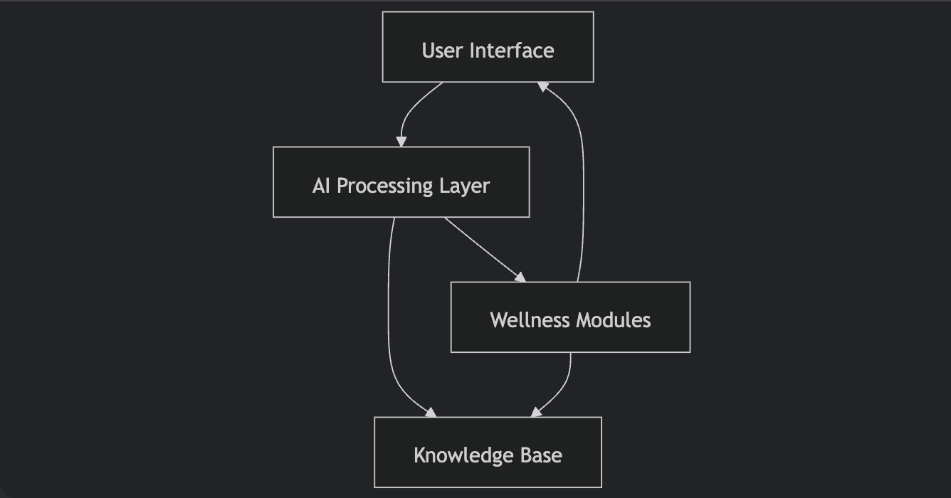

**User Interface Layer (Gradio)**

* Tab-based navigation system
* Real-time chat interface with message streaming
* Interactive wellness tools (sliders/buttons/visual feedback)

**AI Processing Layer**

* LLM Backend: Groq/Llama3-70b (400+ TPS)
* Contextual Understanding:

**Knowledge Management**

* ChromaDB Vector Store (Local Persistence)
* PDF Processing Pipeline:

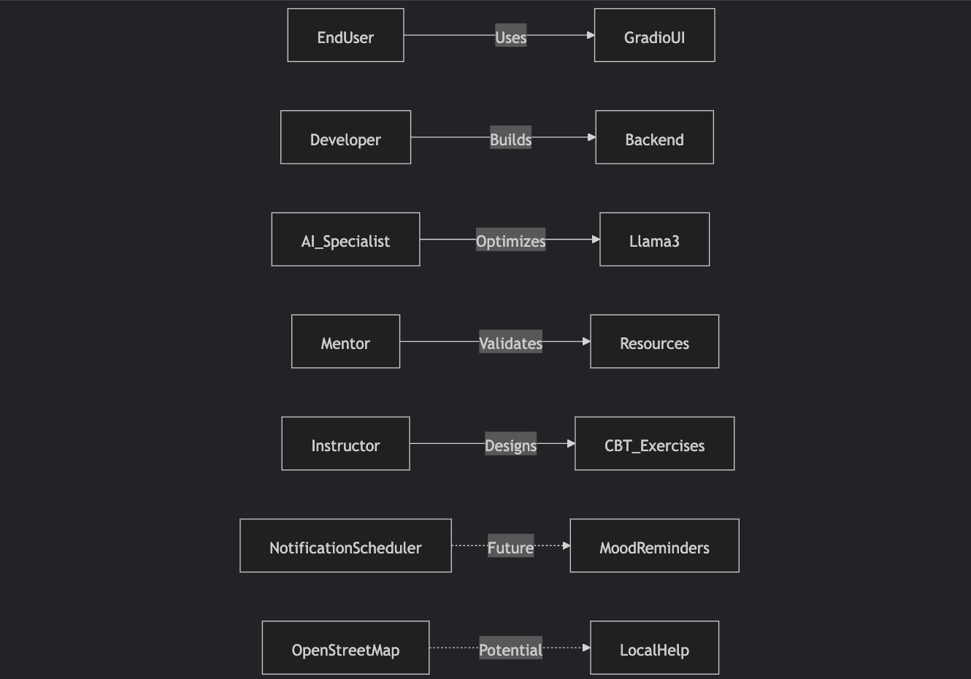

* + 1. Class Diagram

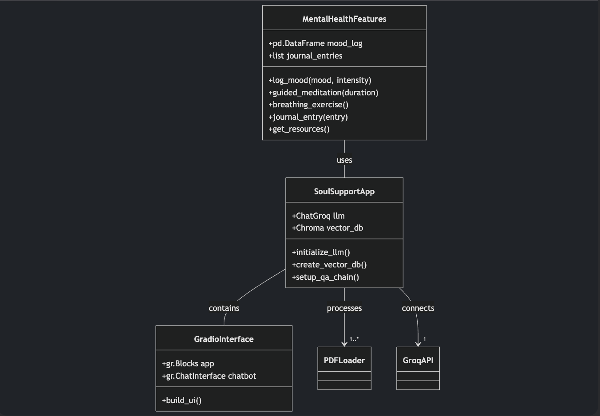

* + 1. Activity Diagrams

A. Chat Interaction Flow

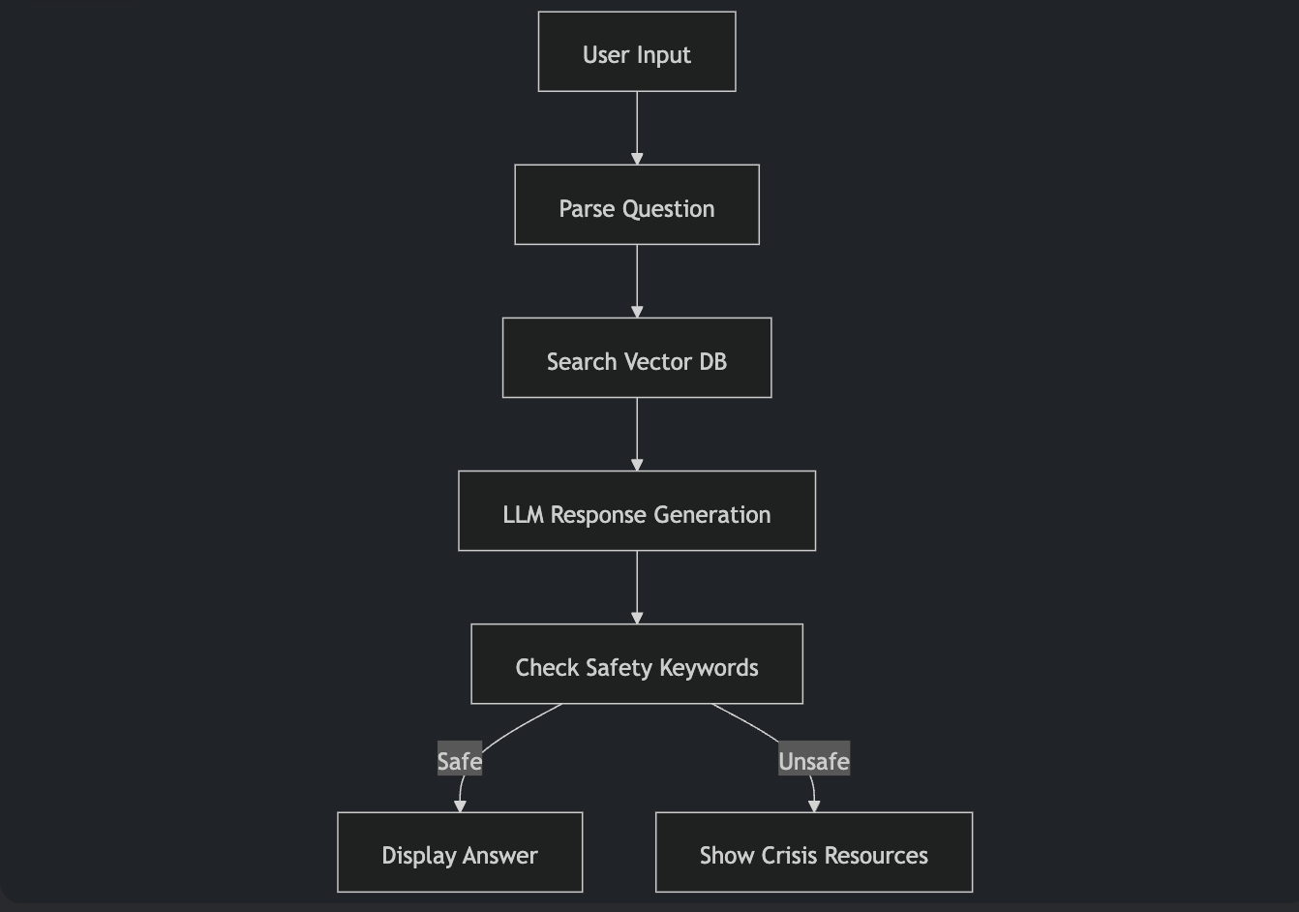

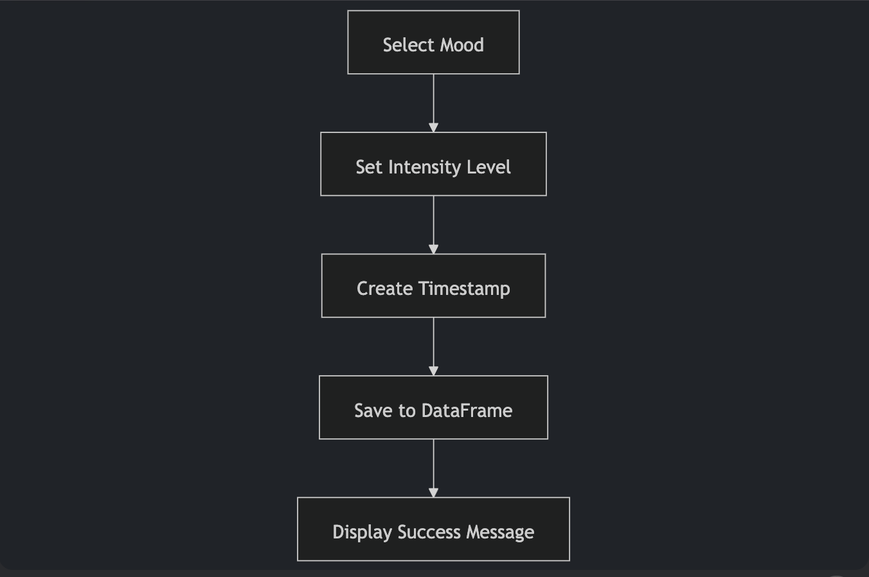

B) Mood Logging Process

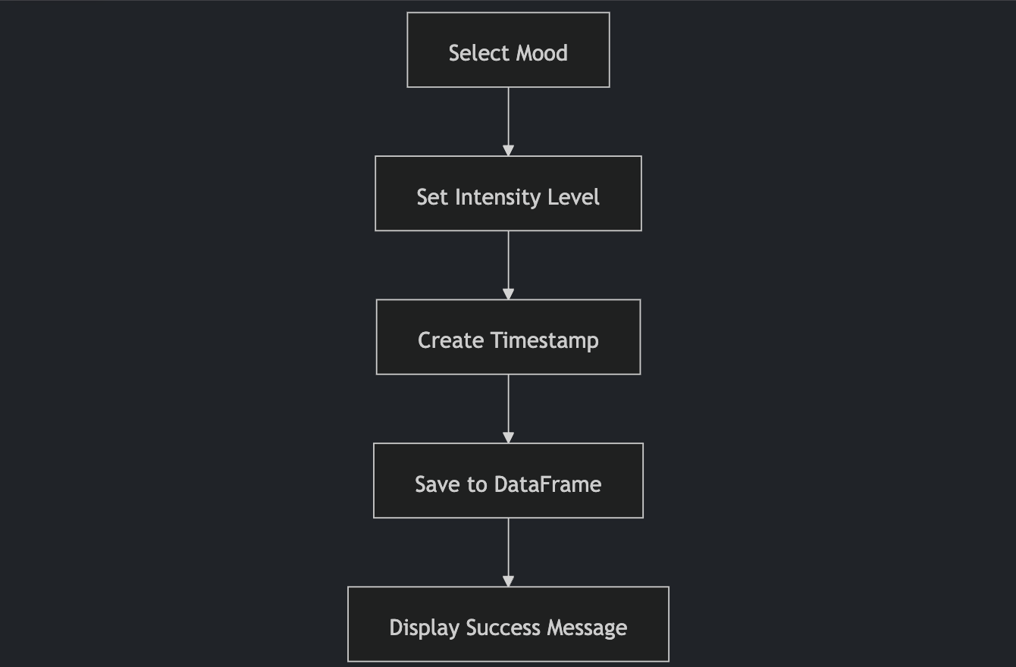

c) Meditation Session Flow

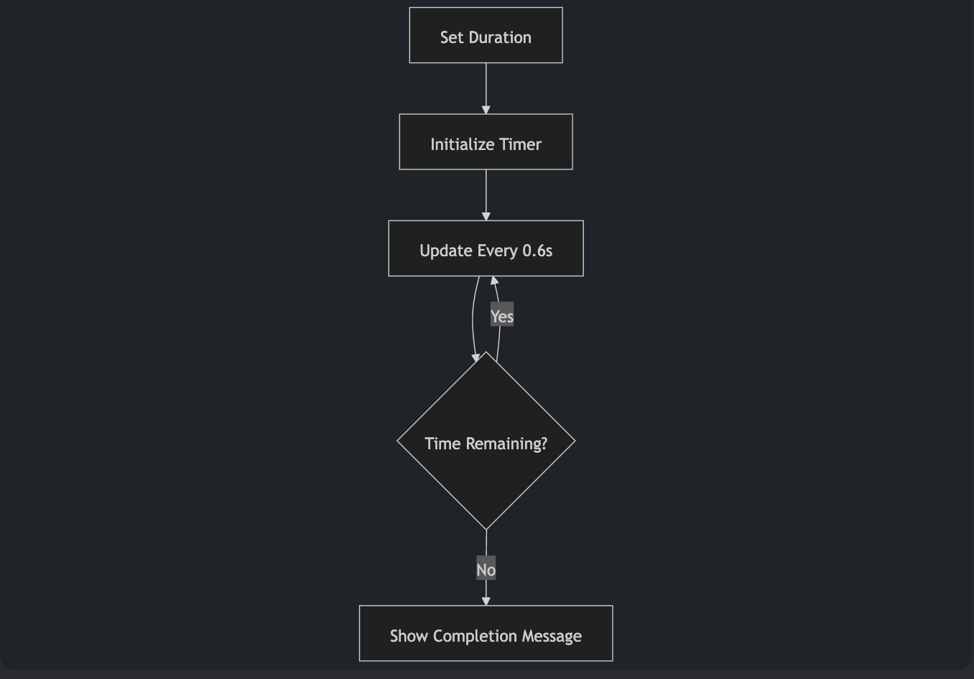

1. User Interface

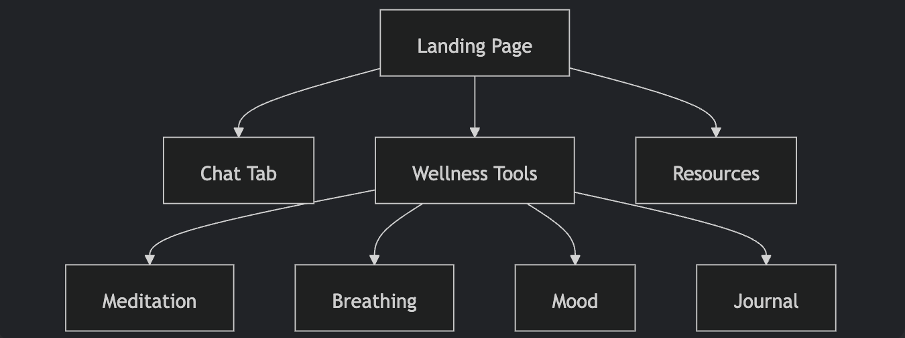

* The Soul Support Bot interface has a three-tab layout optimized for emotional access, utilizing Gradio soft pastel design with emoji-enriched navigation.

The main Chat tab has the conversational interface where the user interfaces with the mental wellness bot, complete with warmup prompts such as "How to manage anxiety?" along with live response streaming.

* The Wellness Tools tab integrates four therapeutic modules: meditation timer with duration adjustable slider (1-30 minutes), visual breathing exercise with animated emoji hints, mood tracker using dropdown emotional states (Happy/Sad/Anxious/Calm/Angry) with intensity sliders, along with journaling interface with auto-save.
* The Resources page boldly displays crisis hotlines with prominent red emojis to catch attention immediately.

Interactive elements utilize progressive visual cues - sliders change colour after adjustment, buttons glow on hovering, along with meditation sessions demonstrating incrementing percentage hints.

* There is responsive design with mobile screen support through collapsible columns, navigation support through the keyboard, and screen reader support.

Persistent session data supports user context between tabs without the need for logins, balancing functionality with regard to privacy.

A subtle footer conceals standard Gradio trademark to preserve therapeutic focus, along with all interactions providing instantaneous confirmation using emoji-derived status messages to support good engagement.

* 1. UI Description

6.2 UI Mockup

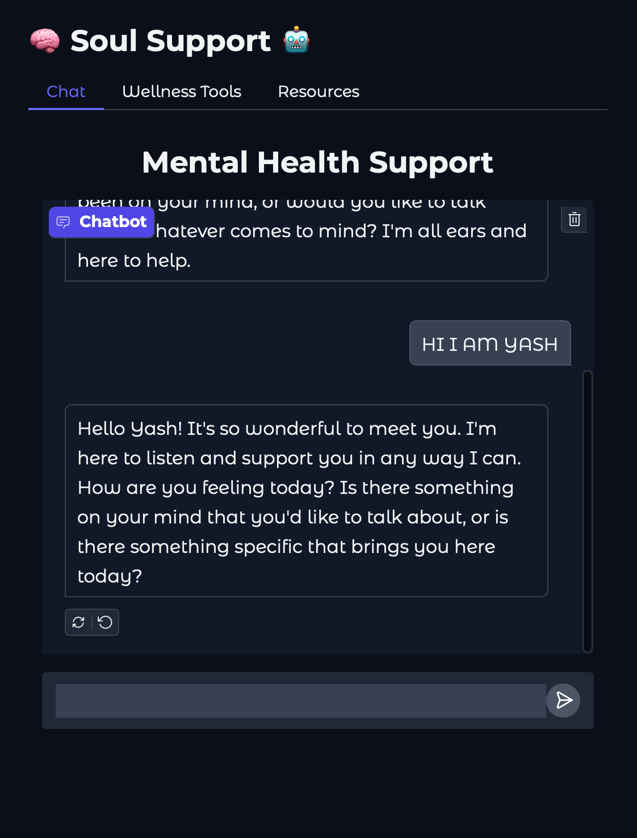

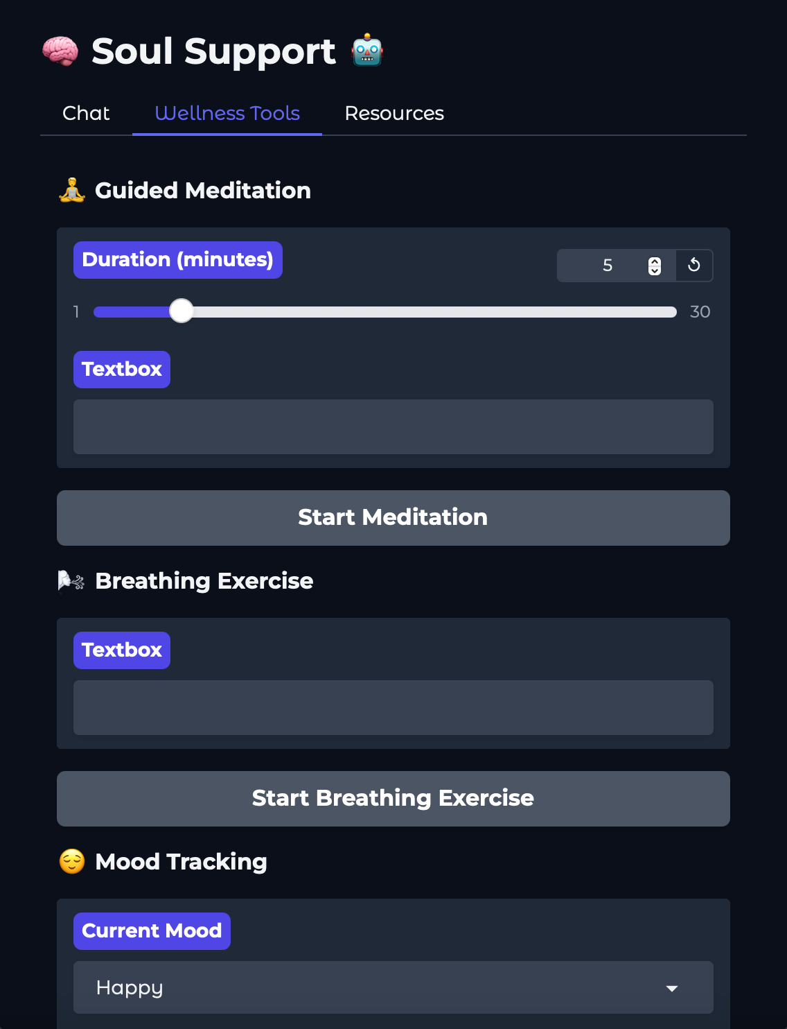

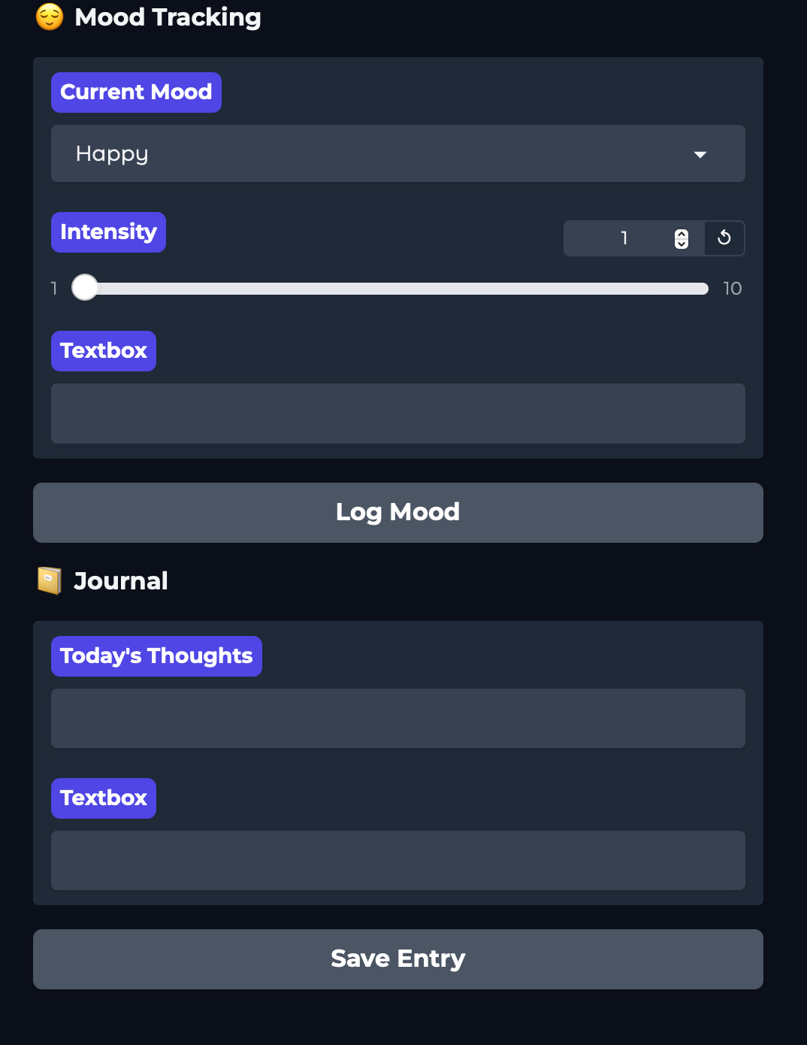

1. Algorithms/Pseudo Code OF CORE FUNCTIONALITY

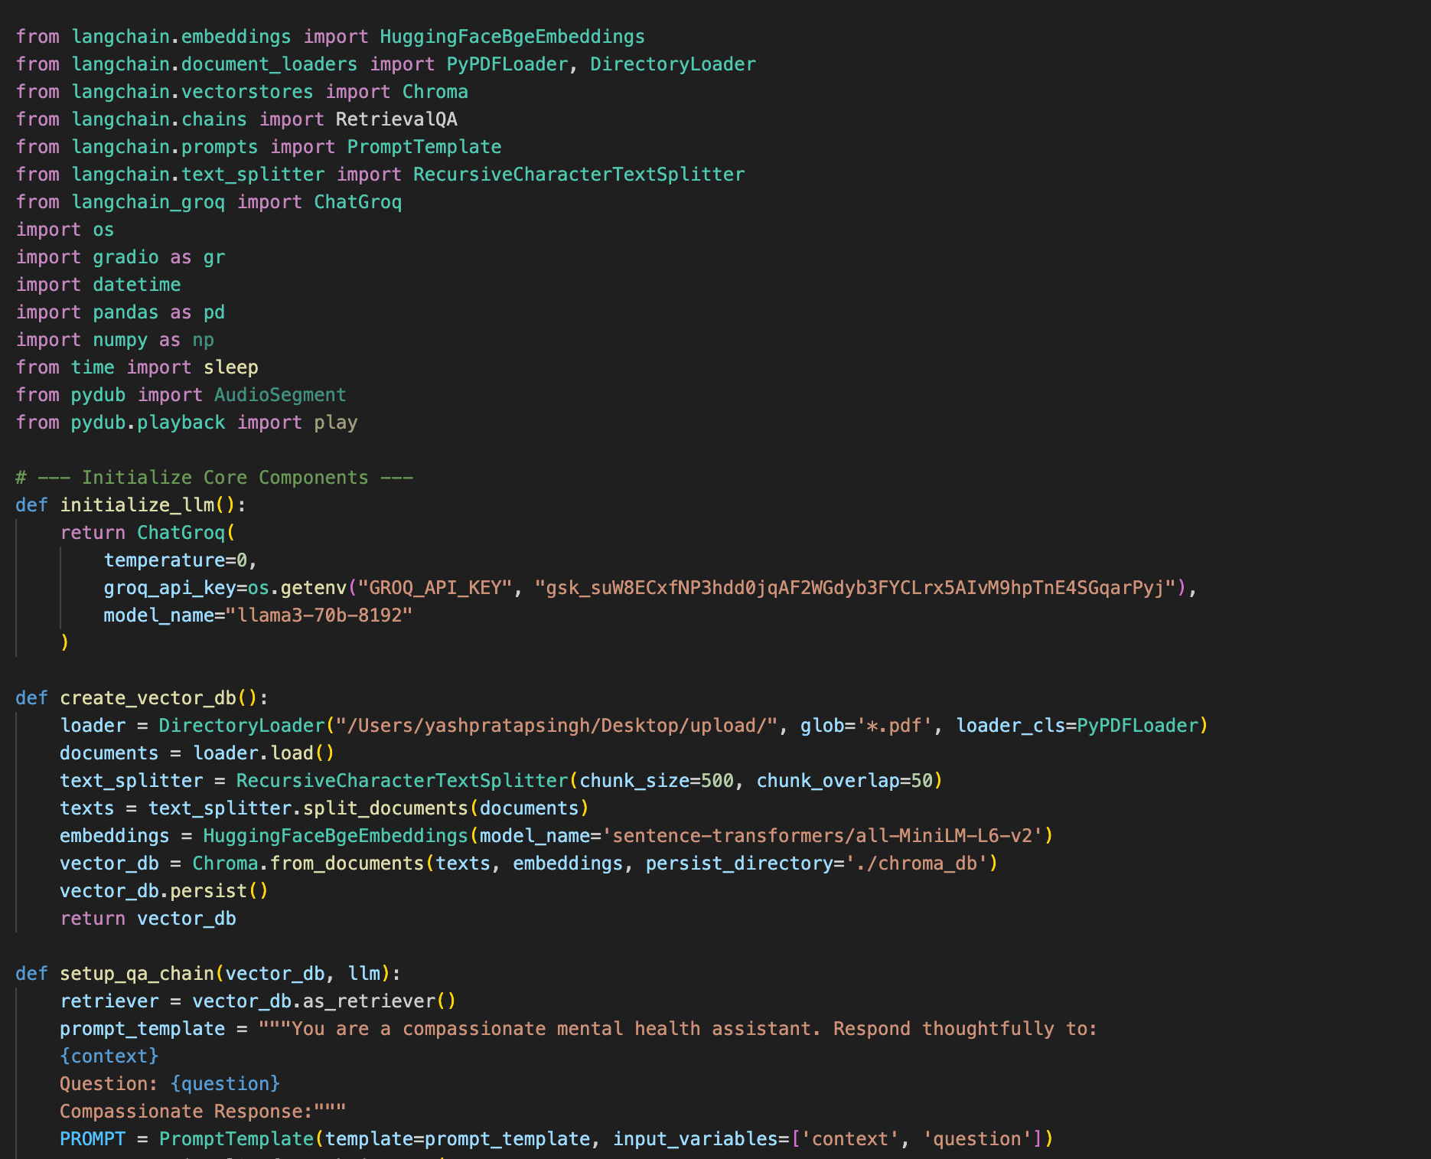

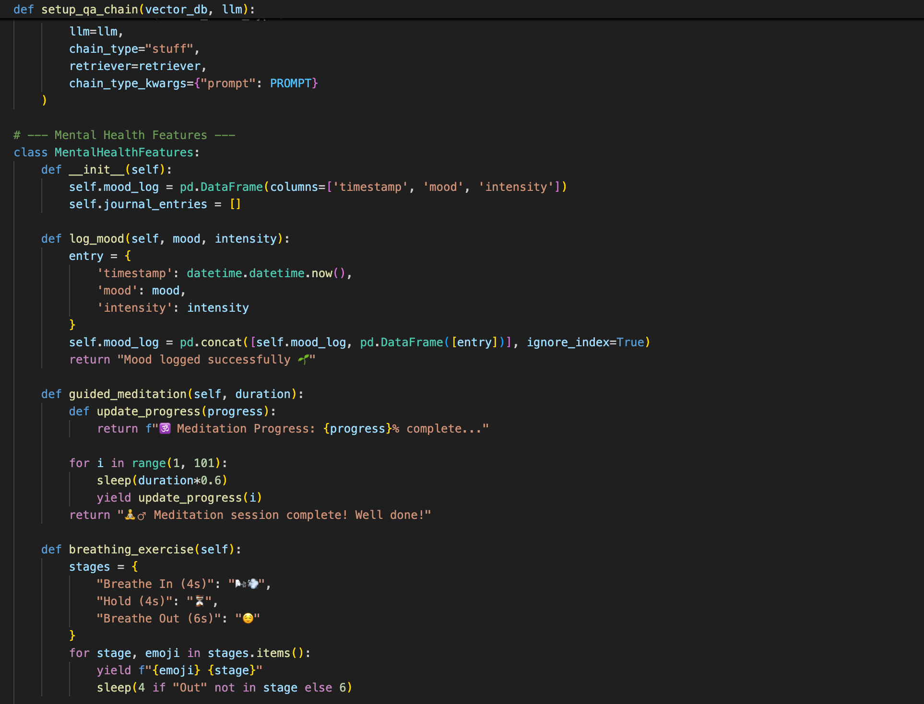

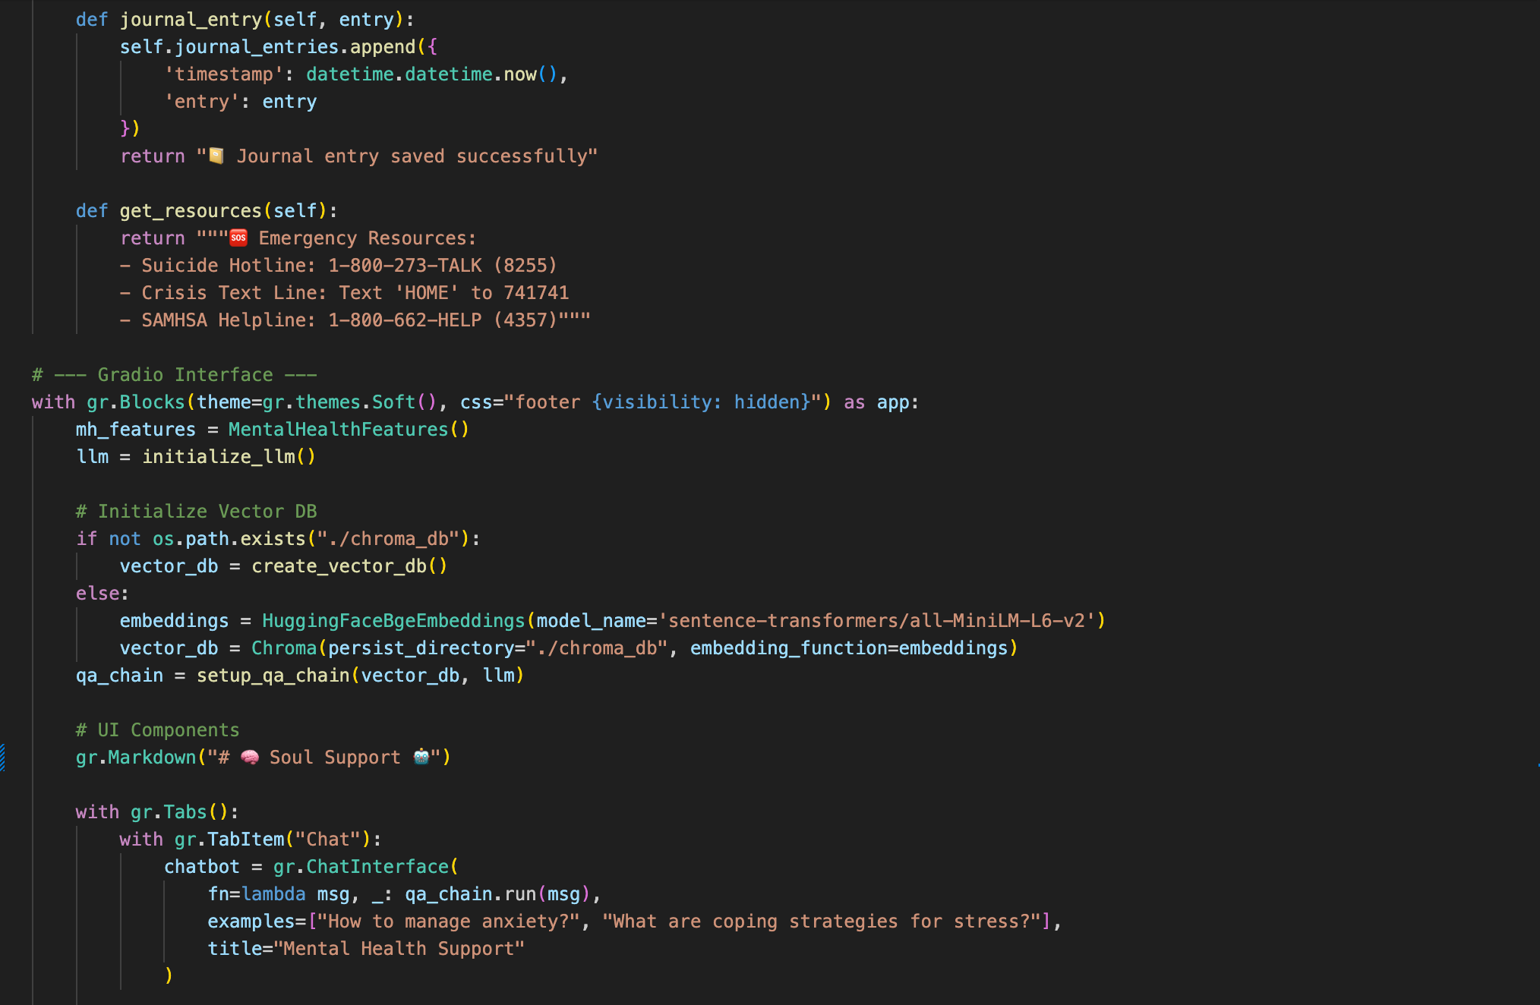

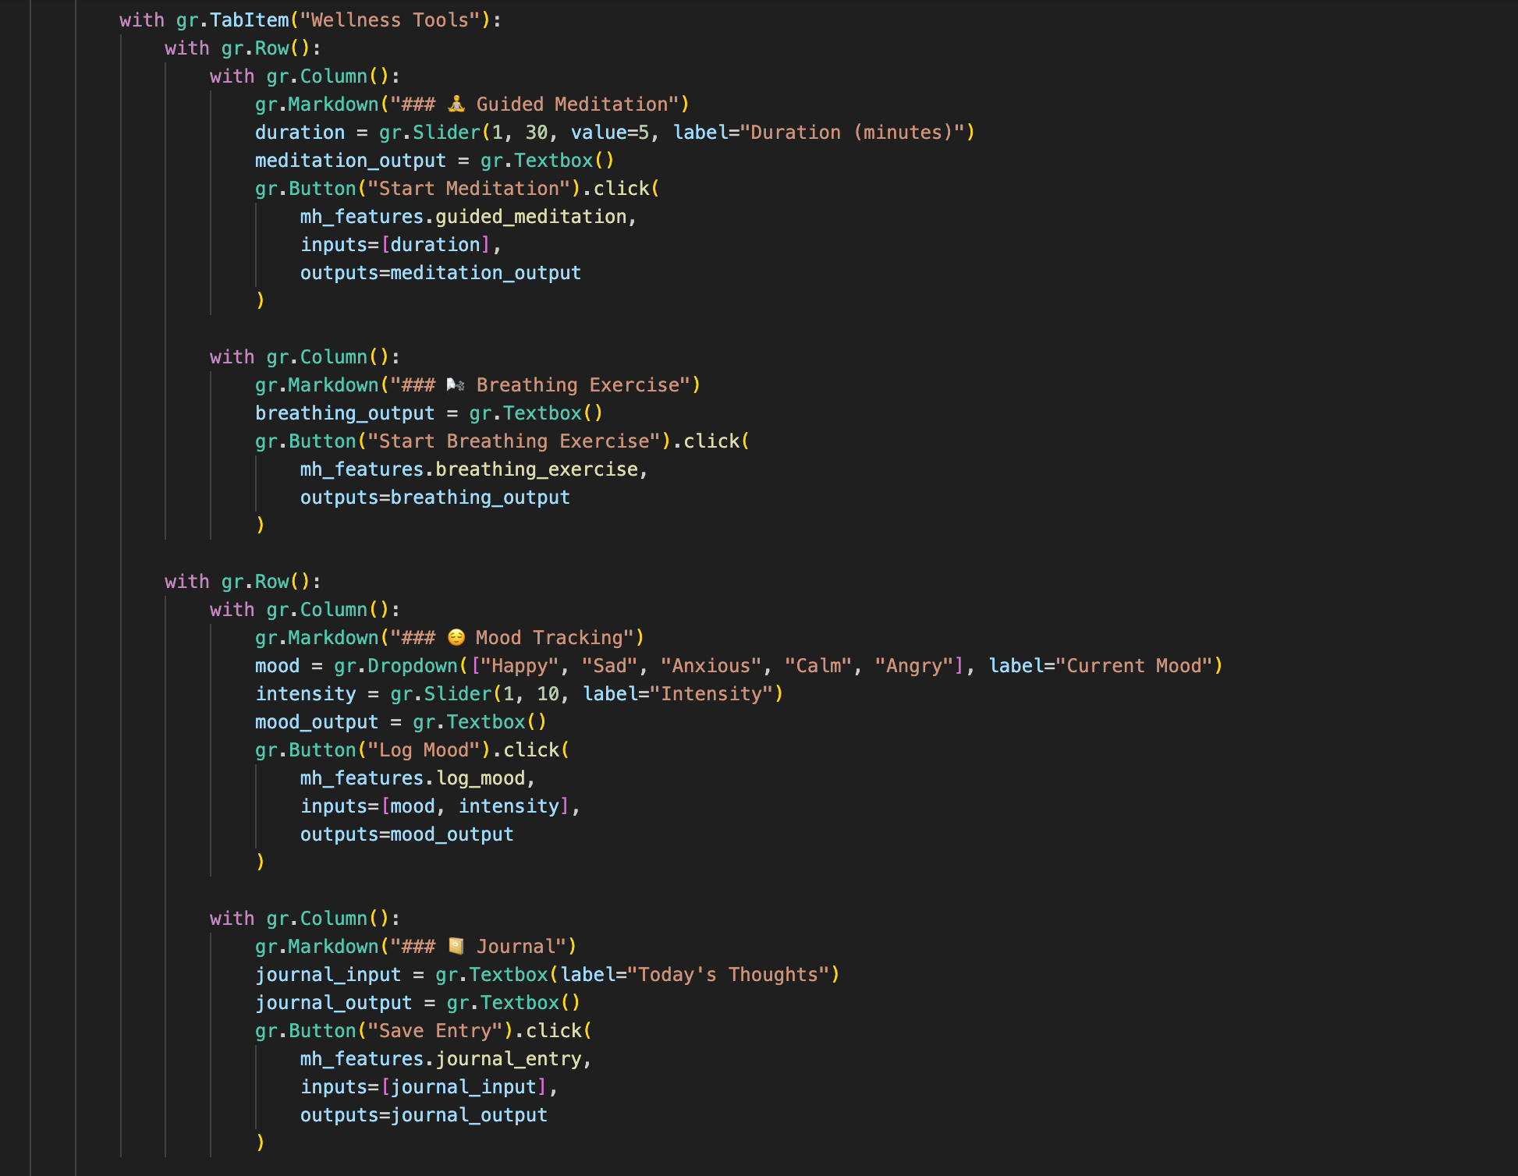

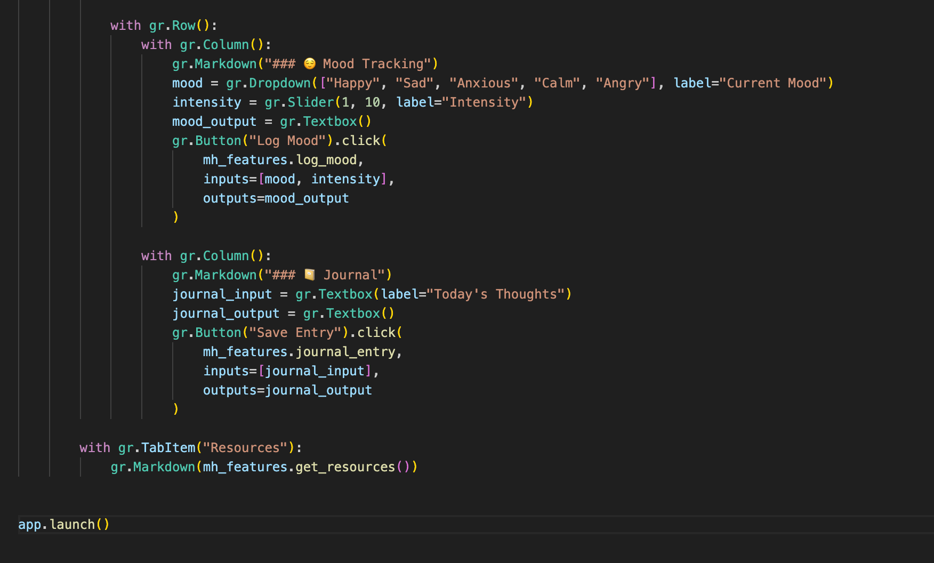

1. Project Closure
   1. Goals / Vision

Vision of the project is to democratize access to mental support through responsible collaboration between human beings and AI, bridging the immediacy of LLMs with evidence-based therapeutic interventions. Some of the innovations include provision of 24/7 access to unjudgmental assistance, reducing anxiety through the utilization of biofeedback tools (e.g., real-time tracking of meditation activity), and facilitating self-awareness using mood/journal analytics It supports an overall mission to that closes the gaps between accessible mental healthcare, underscoring safety through hardcoded crisis resources with response validation. Among the future objectives are clinical validation, scalability internationally using support that is multilingual, community-driven functionality to address social isolation, all the while upholding strict privacy expectations.

* 1. Delivered Solution

The Soul Support mental health bot provides you an AI-Driven conversation and such platform that marries the capabilities of Large Language Model (LLM) with therapeutic resources to provide you emotional support. Developed using Groq’s Llama3-70b for fast inference processing and ChromaDB for knowledge retrieval with context, the platform has three-level interface components: (1) an empathetic AI chat interface using the power of Retrieval-Augmented Generation (RAG) to respond with answers rooted in mental health PDF materials, (2) a wellness toolbox that includes mood logging (emotion intensity-scaled tracking), guided meditation sessions (1–30-minute user-configurable timers), and 4-4-6 breathing exercises, and (3) a crisis resource center with verified emergency hotlines. Accessibility is the focus with the UI based on Gradio with emoji-enhanced interfaces, session persistence, and mobile responsiveness, while keeping privacy intact through local data storage of mood/journal entries and PDF processing.

* 1. Remaining Work

Although the base functionality works, strategic added value is necessary to support scalability and impact.Priority immediate work includes the integration of notification scheduling into wellness check-in, support for voice interaction to make the interface more accessible with the use of hands-free modes, and the establishment of visualisation dashboards to study mood trends using logged information. Technical enhancements like rate limiting, error response to manage problems parsing PDFs, and UI theme customizations outside the default Gradio look are still to be done.Longer-term work will involve establishing partnerships with clinicians to assess therapeutic effectiveness, HIPAA-compliant data handling to protect sensitive data, and external API integration (e.g., OpenStreetMap to find local therapists). Closing these gaps will mature the prototype into an effective, world-accessible resource to aid mental health.

Github Link

<https://github.com/rohan1460>

REFERENCES

**AI & Machine Learning Ui/UX**

Brown, T. B., et al. (2020). Language Models are Few-Shot Learners. arXiv:2005.14165. Chen, M., et al. (2021). Evaluating Large Language Models Trained on Code. arXiv:2107.03374. unacademy.

**Freelancing & Gig Economy**

Kassi, O., & Lehnovirdt , V. (2018). Online labor Index: Measuring the Online Gig Economy. Oxford Internet Institute. Statista. (2023). Global Freelance Platform Market Size. Retrieved from [www.statista.com](http://www.statista.com)

**Debugging & Developer Tools**

Parnin, C., & Orso, A. (2011). Are Automated Debugging Techniques Actually Helping Programmers? ACM ISSTA. Vasic, M., et al. (2019). Neural Program Repair by Jointly Learning to Localize and Repair. arXiv:1904.01720.

**Ethics & Privacy**

European Union. (2018). General Data Protection Regulation (GDPR). Official Journal of the EU. Jobin, A., et al. (2019). The Global Landscape of AI Ethics Guidelines. Nature Machine Intelligence.

**Technical Infrastructure**

MongoDB, Inc. (2023). MongoDB Documentation. Retrieved from docs.mongodb.com OpenAI. (2023). API Reference: Codex. Retrieved from platform.openai.com

**Market Research**

Stack Overflow. (2022). Developer Survey Results. Retrieved from stackoverflow.com/survey GitHub. (2023). State of the Octo verse . Retrieved from git hub blog